**Views & Block**

**Q1:Create a content type named Employee with following fields:**

**Employee name**

**Employee Description**

**Employee ID**

**Picture**

**Salary**

**Skills**

**Competency(taxonomy term)**

**ANSWER 1:**

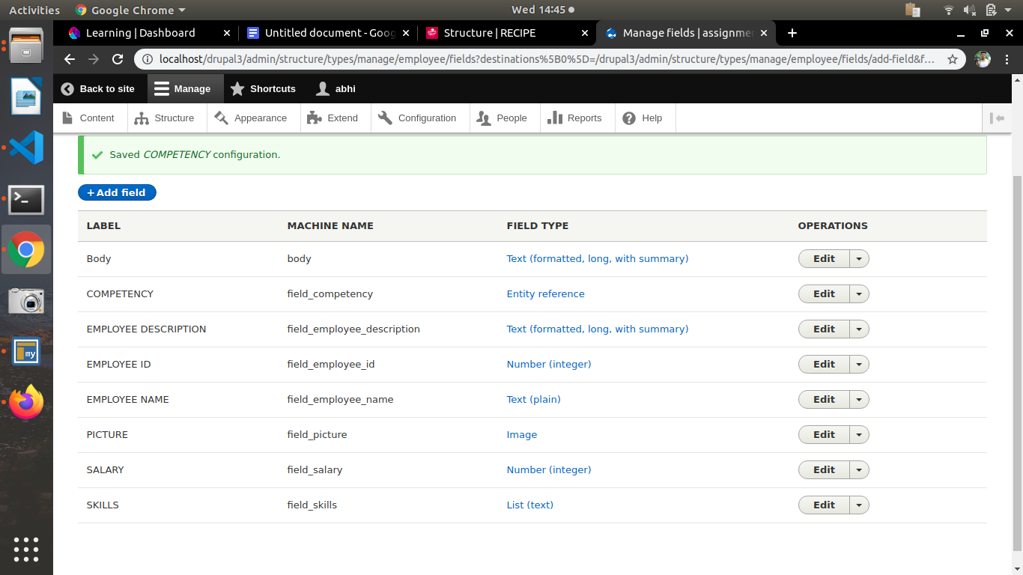

**Q2.Create a block programmatically listing all employee name and Employee ID.**

**ANSWER 2:**

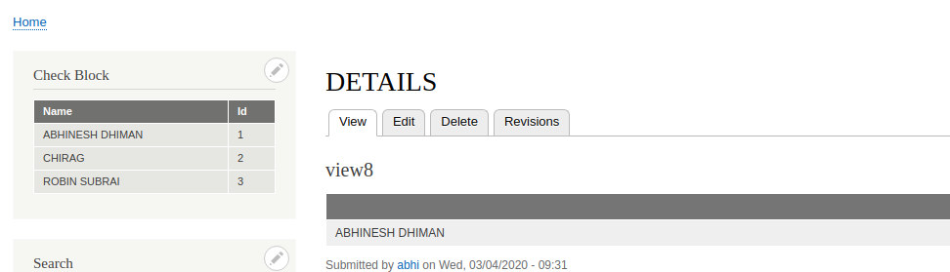

**Q3:Create a view block of employee content type showing employee name and competency in grid format with 3 columns and group them on the basis of competency.**

**ANSWER 3:**

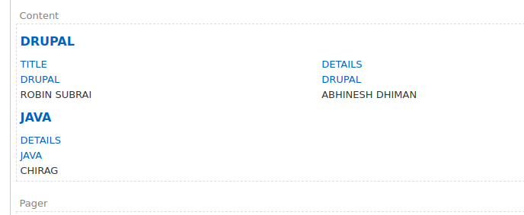

**Q4.List the naming conventions for views templates for views created in question 5 and question 6.**

**ANSWER 4:**

**Q5:Create a view page of employee content type in a table format with Employee name,**

**Employee ID and salary as header**

**1. Sort it on the basis of Employee ID**

**2. Trim the Employee Description field to 50 characters.**

**3. Add header “Total Records found : total”**

**4. Expose the filter for employee name**

**5. Expose the filter for employee id (use Between)**

**ANSWER 5:**

**1:**

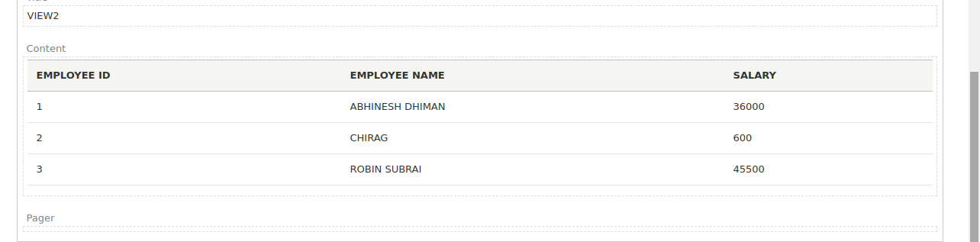

**2**

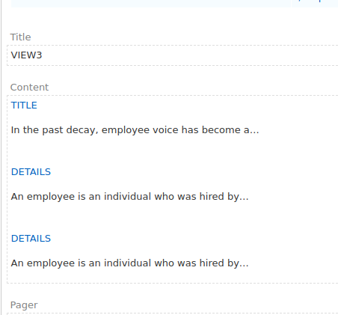

**3:**

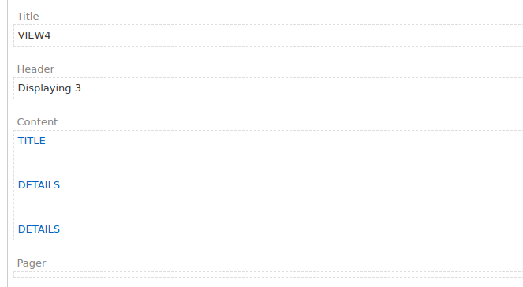

**4:**

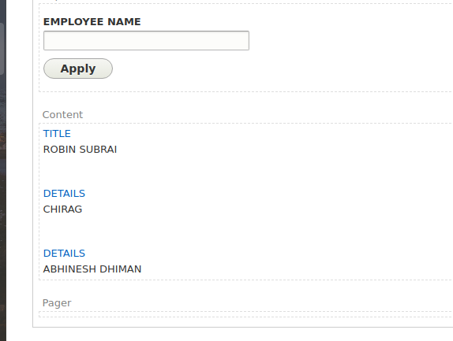

**5:**

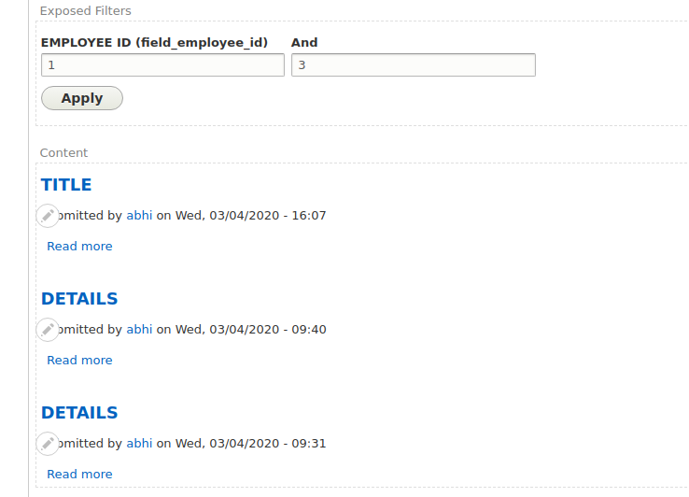

**Q6:Create a view to show the Employee details(name,id) in HTML List on the basis of competency(taxonomy term id)**

**ANSWER 6:**

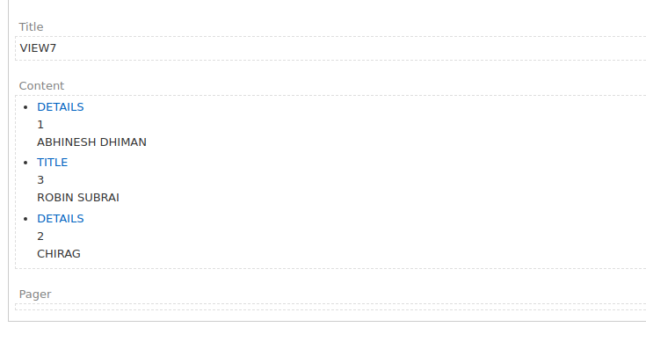

**Q7. Create a view listing Employee name based on node id and show it on employee content type.**

**Note: The title(employee name) should be excluded in which the view is placed.**

**ANSWER 7:**

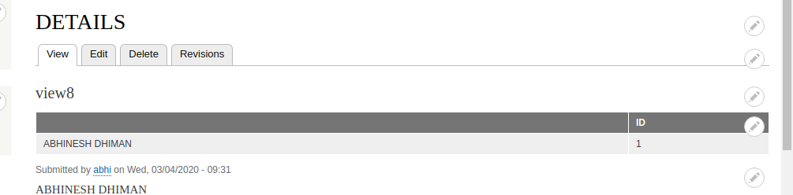

**Q8. Create a form with name and mobile fields and on submit show the field values entered inside a block programmatically.**

**ANSWER 8:**



